OCEANA COUNTY

**4-H SMALL MARKET**

**GEESE RECORD BOOK- 2024**



As a member of the Small Market Animal Project, you are required to submit your records as part of an educational project notebook in order to show your animal at the Oceana County Fair. **This notebook must be shown to the Poultry Superintendent or designated Small Market Weighmaster at the time of weigh-in and then entered by you in the Educational Notebook Division at the Oceana County Fair on Entry Day.**

**AGE: ___________**

The age you enter depends on how old you were on January 1, 2024

**NUMBER OF YEARS IN PROJECT: _____________**

Use this page as the first page of your project record book. Fill it out completely.

**Please print or type neatly**.

# NAME _________________________________________________________________

**4-H CLUB _____________________________________________________________**

##### LEADER ______________________________________________________________

**DATE RECORDS STARTED ________________ DATE ENDED ______________**



## JUDGE’S SCORE/COMMENT SHEET

## (PLEASE DO NOT REMOVE, PLACE THIS SHEET IN SHEET PROTECTOR OR GLUE TO COVER). This sheet must be kept free for the judge to write their comments.

## This sheet should help each 4-H’er understand their ribbon placing.

## A. Specific educational value or worth

## ___ All questions were answered completely

## ___ All calculations were correct

## ___ Calculations were incorrect

## ___ Questions were not answered (missed questions)

## B. Notebook contains all project records

## ___ Notebook contained all project records and were fully completed

## ___ Notebook contained additional project related information (research

## materials etc.)

## ___ Project records were incomplete

## ___There was no additional project related information

## C. Accuracy, neatness and general appearance

## ___Notebook was neat in appearance (typed/hand printed)

## ___Notebook pages were clean and stain free

___Notebook pages were in order and complete

___Notebook was difficult to read and messy

__Notebook had wrinkled and stained pages

Other Comments: _________________________________________________

________________________________________________________________

________________________________________________________________

2024- SMA GEESE PAGE 2

## OBJECTIVES

1. Develop desirable work habits, sportsmanship, and ability to cooperate and express ideas through participation in projects, discussions, method demonstrations, judging teams, and exhibits.
2. Experience the pride and responsibility of leasing/owning and caring for poultry.
3. Learn how to feed, fit, show, breed and raise poultry.
4. Learn proper handling procedures to prevent injuries to 4-H members and their poultry projects.
5. Appreciate and use scientific information in poultry production and marketing.
6. Improve knowledge of grading, marketing and merchandising of poultry and poultry products.
7. Improve knowledge of the nutritive value of poultry meat and eggs and how they contribute toward good health.
8. Learn the importance of the poultry industry to the local, state, and national economies.
9. Acquire information on the opportunity that poultry offers as a career.

This record book is part of your Small Market Geese project. By keeping records up-to-date you will be able to see how much progress you make as you set Goals and work to accomplish them. Write or type neatly and clearly. Please keep the pages in order. Feel free to add extra pages at the end of your notebook.

SCORING CRITERIA

The following breakdown will be used during the judging process of all market livestock notebooks:

A. Specific educational value or worth **30%**

B. Creative way of showing what has been learned **10%**

C. Notebook contains all project records **50%**

D. Accuracy, neatness and general appearance **10%**

2024- SMA GEESE PAGE 3

**ANIMAL MANAGEMENT /JOURNAL OF ANIMAL CARE**

The 4-H SMAA Committee requires all4-H Market Livestock members to complete the “Journal of Care” so the judge may see the time, effort and care you have put into learning about your animal. What did you do to prepare for Fair each month?

* + - Feeding and watering practices
    - Health practices and medicines (vaccinations, etc.)
    - General Management (building a cage, cleaning living area, feed pans, etc.)

**APRIL - MAY**

**JUNE - AUGUST**

If not housed at your home, have the property owner sign. If housed at your home, please have your parent sign.

I do attest and certify that this 4-Her has cared for this animal in a responsible manner while housed on my property. I also understand that integrity and responsibility are important to this 4-H experience.

_________________________________________ ______________

Signature of Property Owner or Parent Date

2024- SMA GEESE PAGE 4

**Describe the type of Geese being used in this project. List breed and variety. Why did you choose this breed?**

________________________________________________________________________

________________________________________________________________________

________________________________________________________________________

________________________________________________________________________

________________________________________________________________________

## WEIGHT CHART

|  |  |  |
| --- | --- | --- |
| Date | Age | **Weight** |
|  |  |  |
|  |  |  |
|  |  |  |
|  |  |  |
|  |  |  |
|  |  |  |

**FINAL WEIGHT (FW)___________ AGE__________ DATE___________**

2024- SMA GEESE PAGE 5

## EXPENSES

##### (A) Cost of goslings $_______________________

|  |  |  |  |
| --- | --- | --- | --- |
| **DATE** | LBS. OF FEED | FEED - VARIETY | COST |
|  |  |  | **$** |
|  |  |  |  |
|  |  |  |  |
|  |  |  |  |
| **(B)** |  | **TOTAL SPENT ON FEED** | **$** |

|  |  |  |
| --- | --- | --- |
| **DATE** | OTHER EXPENSES, VET, SUPPLIES, HOUSING, ETC. | COST |
|  |  | **$** |
|  |  |  |
|  |  |  |
|  |  |  |
| **(C)** | **TOTAL SPENT ON OTHER EXPENSES** | **$** |

##### GRAND TOTAL OF ALL EXPENSES (TE): $ _______________________

##### (total of A+B+C)

**_______________ ÷ _________________ = _______________________________**

Total Expenses **(TE)** Final Weight **(FW)** Break Even Price **(BE)**

(total cost per pound to raise your animal)

***\*\* The breakeven price is the price that you need to get at the***

***Small Market animal auction in order to not lose money on your market project \*\****

2024- SMA GEESE PAGE 6

**MARKETING**

One of the most important parts of any market animal project is marketing; this is how you get someone to come to the auction to buy your animal. It may include things such as writing letters and talking to possible buyers.

* What did you do to market your animal?
* If you had a market project in the past what did you do differently this year?

________________________________________________________________________

________________________________________________________________________

________________________________________________________________________

________________________________________________________________________

**WHOLESALE PARTS OF A GOOSE/DUCK**

**LABEL THE PARTS ON THE PICTURE WITH THE APPROPRIATE LETTER:**

A. DRUMSTICK

B. THIGH

C WING

D. BACK

E. TAIL

F. NECK

G. BREAST

2024- SMA GEESE PAGE 7 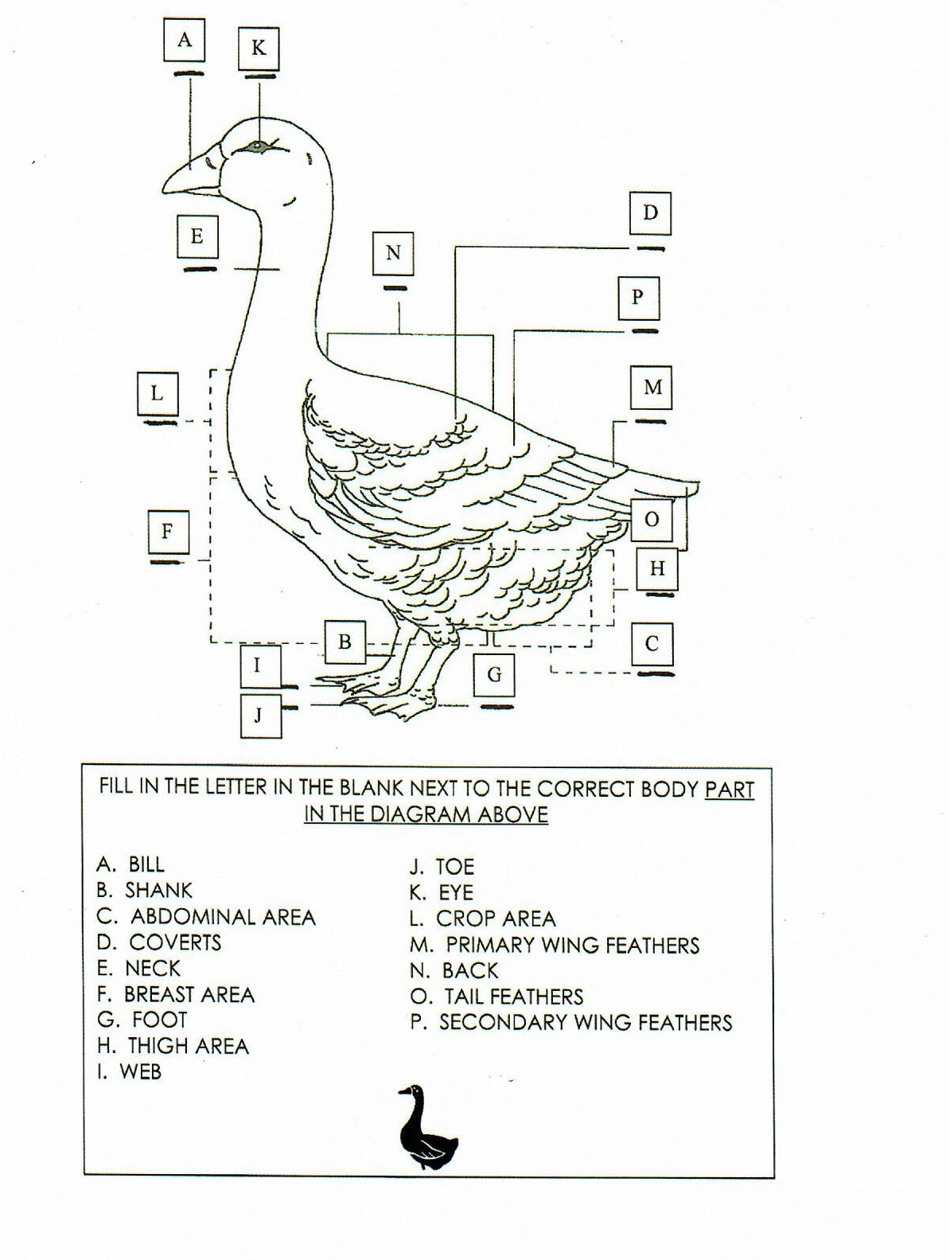

FILL IN THE LETTER IN THE BLANK NEXT TO THE CORRECT BODY PART IN THE DIAGRAM ABOVE

1. NECK J. BREAST AREA
2. SECONDARY WING FETHERS K. SHANK
3. CROP AREA L. FOOT
4. BILL M. TAIL FEATHER
5. THIGH AREA N. TOE
6. ABDOMINAL AREA O. COVERTS
7. EYE P. PRIMARY WING FEATHER
8. WEB
9. BACK



2024- SMA GEESE PAGE 8

**BIRDS DIGESTIVE SYSTEM**

(Write the number of the function with the correct part of the fowl)

_____ Small Intestine

_____ Expandable esophagus

_____ Cloaca

_____ Large, distensible proventriculus

_____ Vent

_____ Beak or bill

_____ Mouth cavity with tongue

_____ Cecum

_____ Large Intestine

_____ Esophagus with crop food

_____ Gizzard

1. Absorbs water from the digested food

2. This is the opening to the outside of the body.

common opening of the digestive, urinary and

reproductive systems.

3. Obtains food and water

4. Digestive appendages without an important

function.

5. “Acid Stomach” produces both acid and

enzymes that breaks down food.

6. Moistens and moves food.

7. Located after the proventriculus is the ventriculus

(stomach) that can grind hard food.

8. Structure into which the large intestine empties.

9. Carries food from mouth to the crop; can stretch

esophagus to allow passage of large pieces of

food.

10. Carries food away from the stomach and absorbs

nutrients from the food with the nutrients traveling

into the blood stream.

11. Is a place to store food that is undigested.

2024- SMA GEESES PAGE 12

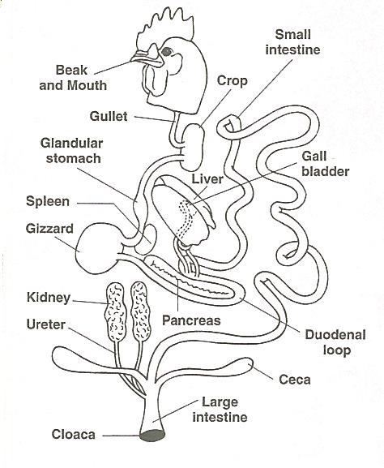

2024- SMA GEESE PAGE 9

## PROJECT PROGRESS AND MANAGEMENT REPORT

1. What did you enjoy/have the most fun doing the most with your project? ­

_________________________________________________________________________

_________________________________________________________________________

_________________________________________________________________________

2. What was the hardest part of your project?_____________________________

_________________________________________________________________________

_________________________________________________________________________

_________________________________________________________________________

3. Will you do the market poultry project again? ____________________

Why or Why not? _____________________________________________________

_________________________________________________________________________

_________________________________________________________________________

4. Would you recommend the breed that you chose for a market project?

________________

Why or Why not? ________________________________________________________

_________________________________________________________________________

_________________________________________________________________________

2024- SMA GEESE PAGE 10

SHOWMANSHIP– CIRCLE THE CORRECT ANSWER TO THE QUESTIONS

1. You and your bird will be judged from the time:

A) That you set the bird on the table

B) From the time that you are asked to get your goose from the carrier

C) From the time that you pose your goose

2. When holding your goose, you should:

A) Hold the goose right in front of you, do not touch its crop to your belly

B) Hold the goose away from your body as not to touch it

C) Hold the goose sideways with its crop touching your belly

3. To pose your goose you should use:

A) Voice Command

B) Your hand only

C) A training stick

4. When posing the goose on the table for the judge:

A) The goose should sit down

B) The goose should not sit down, walk or fly away

C) You should hold the goose in place

5. After posing your goose, if it moves both legs what should you do?

A) Repose your goose

B) Leave it alone

C) Pick up your goose and step back without disturbing the other birds

6. When posing the goose on the table it should:

A) be placed on the table facing the judge

B) be placed on the table facing you

C) be placed on the table sideways so the judge can see the entire bird

7. While showing the goose make sure that you:

1. Be alert, smile and look at the judge from time to time
2. Avoid eye contact with the judge and keep an eye on your goose at all times- never look at the judge
3. Stare at the judge with a serious expression the entire time

8. The four steps of examining the goose are:

A) Examine the tail, examine the vent, measure the public bones, measure

the space between the keel bone and the pubic bone.

B) Examine the shank and legs, examine the toes, examine the webs, examine the feet.

C) Examine the overall general appearance, examine the head, examine the

eyes, examine the bill.

2024- SMA GEESE PAGE 11

**The 4-H Pledge**

(fill in the blanks)

***I pledge…***

My ____________**_____**_____________________ to clearer thinking,

My ____________**_____**_____________________ to greater loyalty,

My ____________**_____**_____________________ to larger service,

and My ____________**_____**_____________________ to better living,

For My ___________________, My ___________________,

My ___________________, and My __________________.

**The 4-H MOTTO:** _______________________________________________________

**SHOWMANSHIP: (list 2 qualities of a good showperson):**

1. _____________________________________________________________________

2. _____________________________________________________________________

**NAME 2 WAYS YOU CAN IMPROVE IN SHOWMANSHIP:**

1. _____________________________________________________________________

2. _____________________________________________________________________

**LIST 1 WAY THAT YOU HELPED OR TAUGHT OTHERS THIS YEAR:**

1. _____________________________________________________________________

2024- SMA GEESE PAGE 12

**MY 4-H STORY**

Interesting things that happened to me and my animal this year, challenges, highlights of my year or anything else I would like to share about my overall 4-H experience.

***POTENTIAL BUYERS NAMES***

As part of your 4-H Small Market Livestock Project, you must personally contact at least three potential buyers before the Oceana County Fair. You are encouraged to seek two new buyers that have not been asked or submitted before. **You also must have at least three different buyers than those of your siblings in the market livestock project.** Please confirm with your buyers their accurate mailing address (example: post office box vs. a street address). The information on page 13 must be completed and taken to the Oceana County MSU Extension Office on or before the due date where it will be **copied** and used to send out letters to your potential buyers. This page will remain in your notebooks. This is a Market Livestock Committee rule. Failure to comply will result in not being able to sell your animal in the 4-H Market Livestock Sale.

2024 SMA Geese Date: _______________

Page 13 Staff: _______________

**SMALL MARKET RABBIT**

**POTENTIAL BUYER’S LIST (ages 8 & up)**

Name______________________________ Club_________________________

***Please print business names and complete addresses clearly.***

* 1. Contact Name ________________________________________________­­____

Business Name ____________________________________________________

**Mailing** Address _________________________City__­­­­­­­­__­­­­­­­_____________Zip_____

Phone _______________________ After Hours Phone______________________

Mailing Preference (Please Check One): Email ____ Postal Delivery ____

Email ____________________________________________________________

Signature__________________________________________________________

2. Contact Name ________________________________________________­­____

Business Name ____________________________________________________

**Mailing** Address _________________________City__­­­­­­­­__­­­­­­­_____________Zip_____

Phone _______________________ After Hours Phone______________________

Mailing Preference (Please Check One): Email ____ Postal Delivery ____

Email ____________________________________________________________

Signature__________________________________________________________

3. Contact Name ________________________________________________­­____

Business Name ____________________________________________________

**Mailing** Address _________________________City__­­­­­­­­__­­­­­­­_____________Zip_____

Phone _______________________ After Hours Phone______________________

Mailing Preference (Please Check One): Email ____ Postal Delivery ____

Email ____________________________________________________________

Signature__________________________________________________________

(Must be stamped by the MSU Extension Office)

2024- SMA GEESE PAGE 14

**PICTURES OF YOUR PROJECT**

(Please use this page for your project pictures. Add additional pages if

you would like. The judges appreciate you labeling the pictures so

they know what the picture shows.)

**CLUB POINTS**

**JUNIOR MARKET/SMALL ANIMAL ASSOCIATION PROJECT**

**ATTENDANCE RECORD**

|  |  |  |  |  |
| --- | --- | --- | --- | --- |
| **MEETING NAME** | **LOCATION** | **DATE** | **POINTS** | **SIGNATURE OF LEADER** |
|  |  |  |  |  |
|  |  |  |  |  |
|  |  |  |  |  |
|  |  |  |  |  |
|  |  |  |  |  |
|  |  |  |  |  |
|  |  |  |  |  |
|  |  |  |  |  |
|  |  |  |  |  |
|  |  |  |  |  |
|  |  |  |  |  |
|  |  |  |  |  |

**Please note:** This form must be included with your record notebook and turned into the weigh master on entry day of the Fair. You need to accumulate **nine (9)** points to be allowed to sell your animal. **Six (6)** of these nine (9) points must come from club meetings. **Three (3)** nonclub points must come from other types of meetings (example: clinics, shows, workshops, fair clean-up and/or county-wide awards).

# *NON-CLUB* POINTS

**JUNIOR MARKET/SMALL MARKET ANIMAL ASSOCATION PROJECT**

**ATTENDANCE RECORD**

***(this must be filled out when presenting for signatures at the office***

|  |  |  |  |  |
| --- | --- | --- | --- | --- |
| **MEETING NAME** | **LOCATION** | **DATE** | **POINTS** | **SIGNATURE OF LEADER, SUPERINTENDENT OR MSU STAFF** |
|  |  |  |  |  |
|  |  |  |  |  |
|  |  |  |  |  |
|  |  |  |  |  |
|  |  |  |  |  |
|  |  |  |  |  |
|  |  |  |  |  |
|  |  |  |  |  |
|  |  |  |  |  |
|  |  |  |  |  |

**Please note:** This form must be included with your record notebook and turned into the weigh master on entry day of the Fair. You need to accumulate **nine (9) points** to be allowed to sell your animal. **Six (6)** of these nine (9)pointsmust come from club meetings. **Three (3)** nonclub points must come from other types of meetings (example: clinics, shows, workshops, fair clean-up and/or county-wide awards).